Robotics (EDPT1009) – Course Project
Milestone 5 Final Report
Martin Morcos, Nada Ehab, Ibrahim Amr, Abdulrahman Khaled, Mohand Mohammed, Mohammed Osama

Abstract
This report presents the final outcomes of the Robotics (EDPT1009) course project, which focuses on the modeling, trajectory planning, simulation, and partial hardware implementation of a 4-degree-of-freedom all-revolute robotic manipulator. Denavit–Hartenberg modeling was employed to derive the forward kinematics, while Jacobian-based formulations were used for velocity analysis and inverse kinematics via the Newton–Raphson method. Semi-circular trajectories were developed to enable surface and internal-volume sanitization tasks. The system was validated using Simscape Multibody and Gazebo simulations, showing consistent behavior with minor offsets due to reference frame differences. Hardware implementation was completed at the component level; however, full-system testing was constrained by power supply limitations.
Keywords: Robotics, DH Convention, Forward Kinematics, Inverse Kinematics, Jacobian Matrix, Trajectory Planning, Simscape Multibody, Gazebo Simulation
INTRODUCTION
Automated paint spraying is a critical process in automotive manufacturing, where high precision and repeatability are required to achieve uniform coating quality and reduce material waste. In this project, a robotic manipulation system is developed to perform precision paint spraying on vehicle surfaces, replacing manual operations that are prone to inconsistency and human error.
Figure 1: Robot Arm
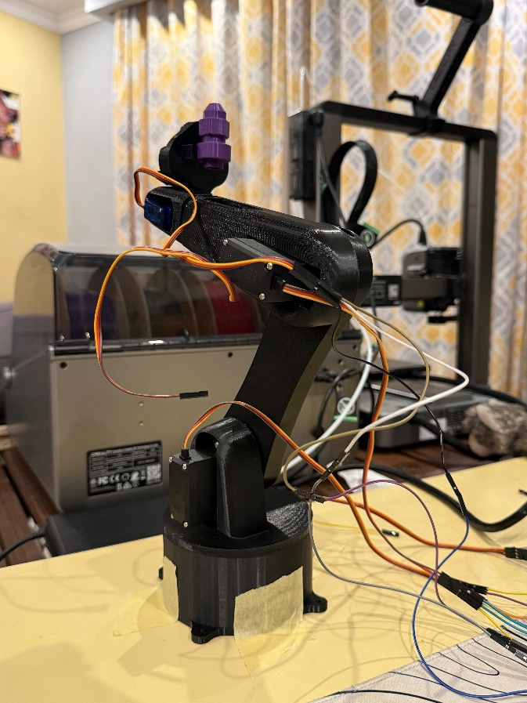
The robot used in this analysis is a multi-degree-of-freedom all-revolute robotic manipulator equipped with a spraying nozzle as its end effector. The manipulator is designed to execute smooth and accurate motions over planar and curved surfaces commonly found in car bodies. Figure 1 illustrates the robotic arm model and its assigned coordinate frames used throughout the analysis.
The analysis performed in this work includes kinematic modeling, trajectory planning, simulation, and partial hardware implementation. Forward and inverse kinematics were derived using the Denavit–Hartenberg convention, while Jacobian-based formulations were used for velocity analysis and inverse position kinematics. Additionally, custom trajectories were developed to represent realistic paint spraying paths and were validated through simulation using Simscape Multibody and Gazebo environments.
The main contribution of this report is the presentation of a complete development framework for a robotic paint spraying system. This includes robot modeling, kinematic analysis, trajectory generation, simulation-based validation, and discussion of hardware implementation constraints. The remainder of this report is organized as follows: hardware components and circuit design are presented first, followed by robot frame assignment and kinematic modeling, simulation results, and finally conclusions and future recommendations.
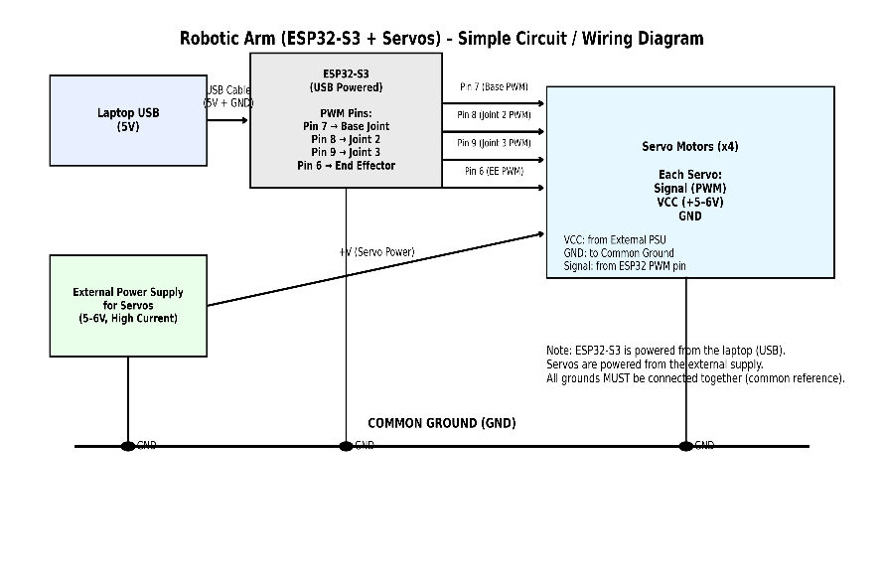
TOPIC 01 – Hardware Components and Circuit Design
To build the robotic paint spraying system, a set of mechanical, electrical, and control components was selected to ensure accurate motion execution and reliable operation. The robotic manipulator consists of multiple revolute joints driven by servo motors, structural links forming the arm, an end effector carrying the paint spraying nozzle, and a centralized control unit.
Figure 2: Circuit Diagram
An ESP32-S3 microcontroller was used as the main control unit of the system. The ESP32-S3 generates pulse-width modulation (PWM) signals to control the angular position of each servo motor. Due to its high processing capability and multiple PWM channels, the ESP32-S3 provides sufficient flexibility for controlling multiple joints simultaneously. Communication between the controller and the actuators is achieved through direct PWM signal lines, while power is supplied externally to meet the current requirements of the motors.
A dedicated external power supply was used to drive the servo motors, while the ESP32-S3 was powered separately to ensure stable logic-level operation. A circuit diagram was designed to illustrate the connections between the ESP32-S3, the servo motors, and the power distribution system. Each motor was tested individually to verify correct electrical connections and control signal integrity. However, due to the high current demand when operating all motors simultaneously, full-system open-loop testing was limited by the available power supply. This limitation highlights the importance of proper power system design in multi-actuator robotic applications.

Table 1: Hardware Components
Component | Quantity | Description / Purpose
ESP32-S3 Microcontroller | 1 | Main control unit generating PWM signals for servo control
Servo Motors | 4 | Actuation of the robotic arm joints (all-revolute configuration)
Robotic Arm Links | 4 | Mechanical links forming the structure of the manipulator
End Effector (Spray Nozzle Mount) | 1 | Holds and guides the paint spraying nozzle
External Power Supply | 1 | Provides sufficient current for servo motor operation
Power Distribution Module | 1 | Safely distributes power to all servo motors
Connecting Wires & Cables | — | Electrical connections between ESP32-S3 and motors

TOPIC 02 – Robot’s Frame Assignment
To perform systematic kinematic modeling of the robotic manipulator, coordinate frames were assigned to each joint following standard robotics conventions. Proper frame assignment is a fundamental step in the methodology, as it establishes a consistent reference system for deriving the transformation matrices and subsequent kinematic equations.
The robotic system under study is a multi-degree-of-freedom all-revolute manipulator used for precision paint spraying applications. A base coordinate frame, denoted as Frame 0, was fixed at the robot base and serves as the global reference frame for the entire system. Subsequent coordinate frames were assigned sequentially to each joint along the kinematic chain, with the final frame attached to the end effector where the paint spraying nozzle is mounted.
Each coordinate frame was defined such that the z-axis aligns with the axis of rotation of the corresponding joint, while the x- and y-axes were chosen to satisfy the right-hand rule and simplify the Denavit–Hartenberg parameter definition. This consistent assignment ensures that joint rotations and link transformations can be described accurately and compactly.
Figures illustrating the assigned coordinate frames from the base to the end effector are shown in Figures 3–6. These frames form the basis for the DH convention table presented in the following section and are essential for deriving both the forward and inverse kinematics of the robotic manipulator.

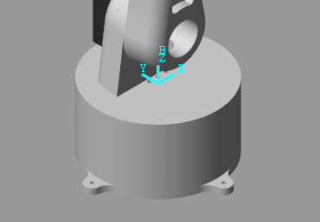
Figure 3: Frame 0
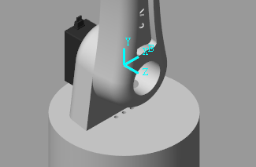
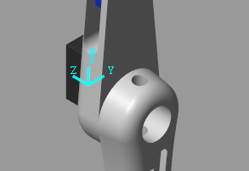
Figure 4: Frame 1
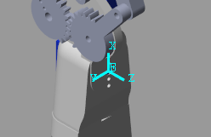
Figure 5: Frame 2
Figure 6: Frame 3

TOPIC 03 – Methodology (DH Convention and Kinematic Modeling)
This section presents the second topic in the methodology used in this work, which is the kinematic modeling of the robotic manipulator using the Denavit–Hartenberg (DH) convention. The DH convention provides a systematic approach for describing the spatial relationship between consecutive links of a robotic manipulator using a minimal set of parameters.
Based on the coordinate frames assigned in the previous section, a DH parameter table was constructed to define the geometry of the multi-degree-of-freedom all-revolute robotic arm. For each joint, four parameters were identified: the link length, link twist, link offset, and joint angle. These parameters uniquely describe the relative position and orientation between successive coordinate frames along the kinematic chain.
Using the DH parameters, homogeneous transformation matrices were derived for each link. These matrices represent the rotation and translation from one coordinate frame to the next. The overall transformation from the base frame to the end-effector frame was obtained by multiplying the individual transformation matrices sequentially. This formulation enables the computation of the end-effector position and orientation as a function of the joint variables, which is essential for both forward and inverse kinematic analysis.
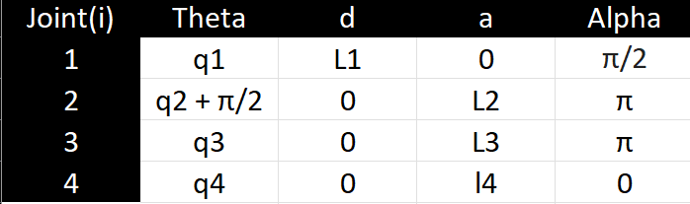
The DH parameter table used in this project is presented in Table 2, while the corresponding transformation matrices are used in subsequent sections to derive the forward kinematics, inverse position kinematics, and Jacobian matrix. This kinematic model forms the foundation for trajectory planning and simulation of the robotic paint spraying system.
Table 2: DH Convention

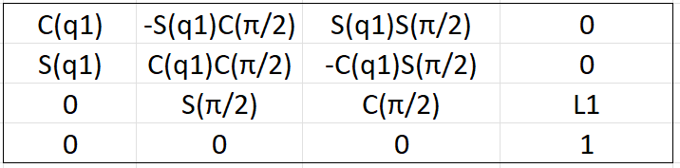
⁰T₁ =
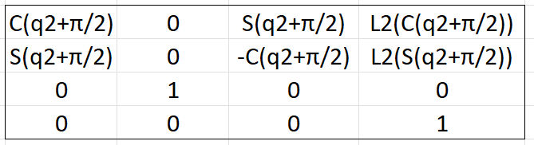
¹T₂ =

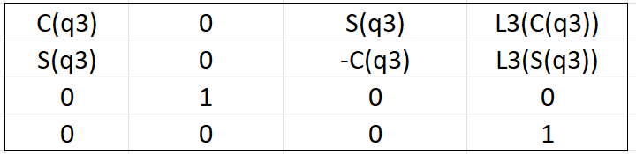
²T₃ =

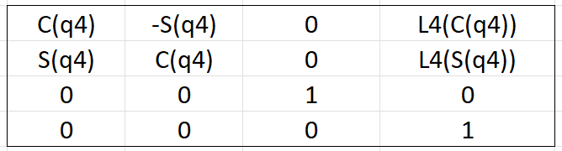
³T₄ =

⁰T₄ = ⁰T_{1 *} ¹T_{2 *} ²T_{3 *} ³T₄

Trajectory Planning
Trajectory planning is a critical component in robotic paint spraying applications, as it directly affects surface coverage quality, coating uniformity, and motion smoothness. In this project, smooth and continuous trajectories were developed to guide the end effector carrying the paint spraying nozzle along predefined paths that emulate realistic automotive painting motions.
To ensure smooth motion and continuous velocity profiles, semi-circular trajectories were adopted. These trajectories allow the robotic manipulator to maintain consistent movement while avoiding sudden changes in joint positions, which is essential for achieving uniform paint deposition. The trajectories were formulated in task space and later mapped to joint space using the kinematic model derived in the previous sections.
Two main trajectory profiles were developed. The first trajectory enables planar surface coverage, representing the motion required to spray flat vehicle body panels such as doors or hoods. The second trajectory follows a curved path around the robot, simulating paint spraying over curved automotive surfaces. These trajectories ensure full surface coverage while respecting the physical joint limits of the robotic manipulator.
The mathematical equations used to generate the semi-circular trajectories are presented below, followed by plots illustrating the resulting end-effector paths. These trajectories were later used as inputs for simulation in both Simscape Multibody and Gazebo environments to validate motion feasibility and smoothness.
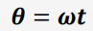
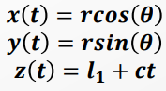

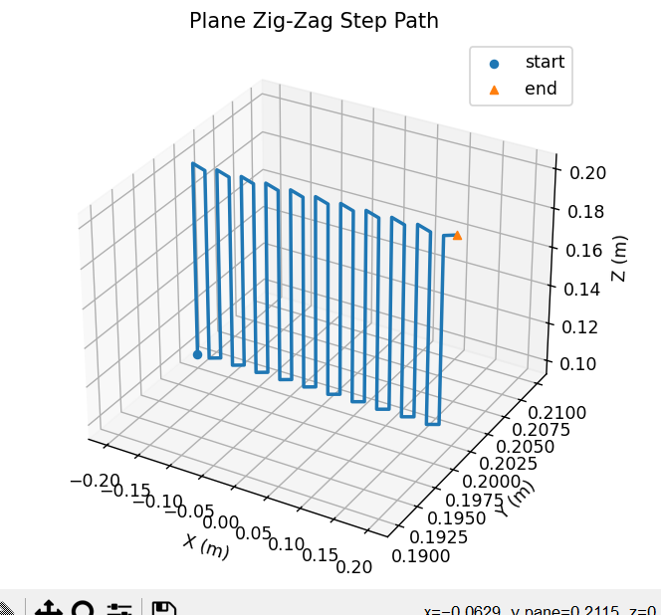
Figure 7: Trajectory 1

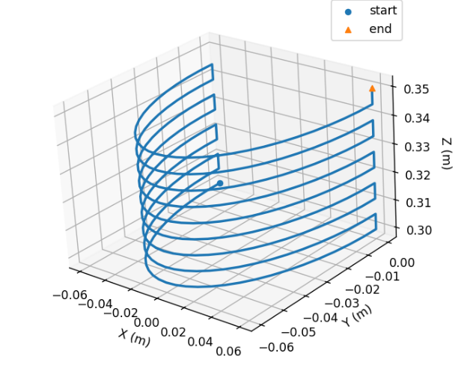

Figure 8: Trajectory 2

Inverse Position Kinematics

Inverse position kinematics is used to determine the joint variables required for the robotic manipulator to reach a desired end-effector position. For the all-revolute robotic arm, the inverse kinematics problem is formulated by defining the task-space position vector $X(q)=[x(q),y(q),z(q)]^{T}$, which is extracted from the forward kinematics transformation matrix.
The inverse kinematics problem is expressed as a nonlinear error function:
$$F(q)=X(q)-X^{d}=0$$
where $X^{d}$represents the desired end-effector position. Due to the nonlinear nature of the equations, a numerical Newton–Raphson method was employed to iteratively compute the joint variables.
The iterative update is given by:
$$q^{k+1}=q^{k}-J(q^{k})^{-1}\left(X(q^{k})-X^{d}\right)$$
where $J(q)$is the Jacobian matrix relating joint variations to end-effector position changes. This approach enables accurate computation of feasible joint configurations while respecting the physical constraints of the robotic manipulator.

Velocity Kinematics and Jacobian Analysis

Velocity kinematics describe the relationship between joint velocities and end-effector linear and angular velocities. This relationship is expressed using the Jacobian matrix as:
$$\dot{X}=J(q)\dot{q}$$
where $\dot{X}$represents the end-effector velocity vector and $\dot{q}$denotes the joint velocity vector.
For the all-revolute robotic manipulator, the Jacobian matrix was constructed using standard geometric relationships based on joint axes and link positions. Since the system is kinematically redundant, inverse velocity kinematics were computed using the pseudoinverse of the Jacobian:
$$\dot{q}=J^{+}\dot{X}$$
This formulation enables smooth and feasible motion generation for trajectory execution and is used in the simulation stage of the project.

SIMULATION RESULTS
The robotic paint spraying system was simulated to validate the kinematic model, trajectory planning, and overall motion feasibility before full hardware testing. Two simulation environments were used in this project: MATLAB/Simscape Multibody and Gazebo. These platforms provide realistic visualization and physics-based validation of robotic motion and allow comparison of system behavior across different simulation tools.
The robot model was constructed in the simulation environments using the same geometric and kinematic parameters defined in the modeling stage. The manipulator consists of multiple rigid links connected through revolute joints. The link dimensions, including length, width, and thickness, were defined according to the mechanical design used in the hardware assembly to ensure consistency between simulation and real-world implementation.
The planned semi-circular trajectories were applied to the robotic manipulator in both simulation environments. In Simscape Multibody, the robot motion was visualized in three-dimensional space, allowing observation of joint rotations, end-effector paths, and overall system stability. Similarly, Gazebo was used to simulate the same joint trajectories and provide an alternative physics-based visualization of the robot’s motion.
Figure 9: QR Code
Figure 10 shows the Simscape Multibody block diagram. Figures 11 and 12 present screenshots from the Simscape Multibody and Gazebo simulation environments, respectively, illustrating the robotic manipulator executing the planned paint spraying trajectories. These figures provide visual confirmation of correct system implementation and demonstrate the robot’s functional behavior during motion execution.
The simulation results demonstrate smooth and continuous motion of the robotic arm along the planned trajectories, with the end effector accurately following the desired paint spraying paths. Minor differences were observed between the Simscape and Gazebo outputs due to differences in reference point tracking and internal simulation models. However, these variations were small and did not affect the physical feasibility of the motion. All joint configurations remained within the allowable servo motor limits, confirming the validity of the kinematic and trajectory planning approach.

To further support the presented results, a QR code is provided that links to demonstration videos of the robotic system. These videos include the Simscape Multibody simulations, Gazebo simulations, and available hardware testing, offering a visual verification of the robot’s motion, trajectory execution, and system behavior across different platforms.
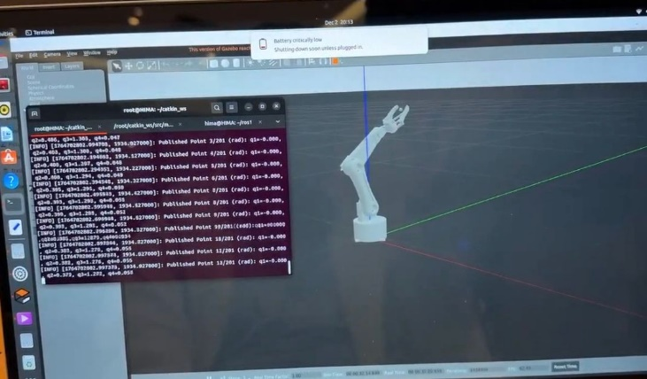
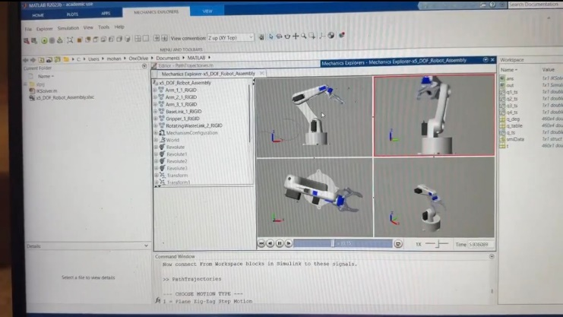
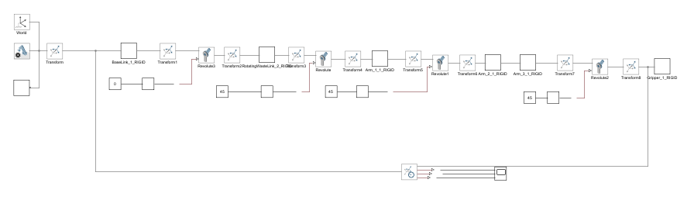
Figure 12: Screenshot from Simscape
Figure 10: Simscape Multibody block diagram
CONCLUSIONS AND FUTURE RECOMMENDATIONS
This project presented the modeling, trajectory planning, simulation, and partial hardware implementation of a multi-degree-of-freedom robotic manipulator designed for precision automotive paint spraying applications. The work began with systematic frame assignment and kinematic modeling using the Denavit–Hartenberg convention, followed by the derivation of forward and inverse kinematics. Semi-circular trajectories were developed to ensure smooth and continuous end-effector motion suitable for uniform paint application on planar and curved surfaces.
The proposed kinematic model and planned trajectories were validated through simulation using MATLAB/Simscape Multibody and Gazebo environments. The simulation results demonstrated smooth joint motion and accurate trajectory tracking, with the end effector successfully following the desired paint spraying paths. Minor differences observed between the simulation platforms were attributed to variations in reference frame tracking and internal physics engines; however, these differences did not affect the physical feasibility of the robotic motion. All joint configurations remained within the allowable servo motor limits, confirming the validity of the modeling and trajectory planning approach.
Figure 11: Screenshot from gazeebo
Overall, the outcomes of this project confirm the effectiveness of the adopted methodology in achieving precise and feasible robotic motion for paint spraying tasks. However, several limitations were identified during the implementation phase. Mechanical limitations were encountered in some servo motors, where plastic internal gears were prone to wear and breakage under load, requiring component replacement. This affected the robustness and long-term reliability of the hardware system. Furthermore, the absence of feedback sensors limited the system to open-loop operation, reducing positioning accuracy under external disturbances and load variations.
Future work will focus on addressing these limitations by employing metal-geared servo motors for improved mechanical durability, integrating a high-current and regulated power supply, and implementing closed-loop control using position and torque feedback. Additional improvements include refining trajectory planning for complex vehicle geometries, enhancing structural rigidity, and performing full experimental validation of the robotic system. These enhancements will contribute to building a fully functional, reliable, and industry-relevant robotic paint spraying system suitable for real-world automotive applications.

